**Focus keyword**: **Liteboxer Fitness Bundle**

**Meta Title:**– **Liteboxer Fitness Bundle** |**Vigoursoul**

**Meta Description**: Liteboxer Fitness Bundle includes modern TM, Muscle, and at-home training are all included in the innovative exercise.

**Feature Image:**

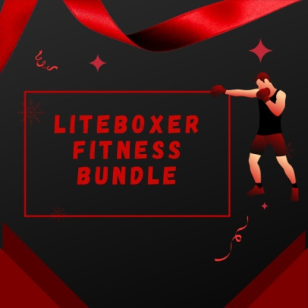

**Liteboxer Fitness Bundle**

**Liteboxer Fitness Bundle** or Boxing, also known as "Western boxing," or "pugilism," is a combat sport in which two opponents trade blows for a set period of time inside a boxing ring while typically donning protective gloves and other safety gear like hand wraps and mouth guards.

Despite the fact that the term "boxing" is typically associated with "western boxing," in which only the fists are used, boxing has evolved in various ways across various regions and cultures.

**Liteboxer Fitness Bundle**

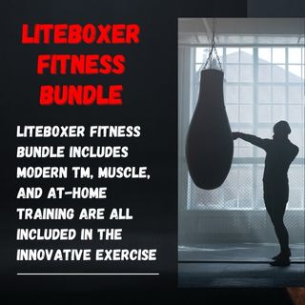

The **Liteboxer Fitness Bundle** is a unique fitness gadget that combines state-of-the-art TM, Muscle, and at-home training to provide a stimulating and efficient boxing workout. With the help of the IOS and Android software Liteboxer, users may have a guided workout with experienced boxing trainers set to lights and music.

**How Does Liteboxer App Work?**

Due to the sensors that are already inside the **Liteboxer Fitness Bundle**, users can also monitor their progress over time by monitoring how hard, for how long and how accurately they are punching. An expansive space is needed for the all-in-one home boxing system known as the **Liteboxer Fitness Bundle**. The area required for the Liteboxer Fitness Bundle after construction is 37.5 inches by 55.5 inches.

**Oxer Fitness Bundle**

Although having the demo unit set up in my living room wasn't exactly a hassle, it did create for some interesting times. Make sure you have a fantastic leisure room set aside for Liteboxer to enjoy. I believe that facilities like garages and unfinished basements at home are the finest locations to exercise. The **Liteboxer Fitness Bundle** hardware kit, which costs $1,695, will ship in two different containers. You can ask the business to install a white glove for you if you don't want to put it together yourself.

**Boxer Stand**

The centre punching shield, a pedestal with an adjustable tablet mount, and a standing platform are all included in this set (two pieces). The size of your boxing area can be increased by 20 inches by purchasing a third platform segment if you feel that you need more space for your training. You will also receive some hand wraps, boxing gloves, general assembly hardware, and hex wrenches from us.

**Liteboxer Floor Stand**

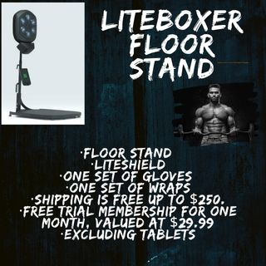

Purchase of a separate **Liteboxer Fitness Bundle** membership is necessary. You can get your first three months of membership for free when you purchase a Liteboxer for a limited period. Choose between the Monthly ($29.99/mo) and Annual ($27.50/mo) plan options after three months.

Price: 36 dollars, or $1295 a month.

**Package contains:**

* Floor Stand
* Liteshield
* One set of gloves
* One set of wraps
* Shipping is free up to $250.
* Free trial membership for one month, valued at $29.99
* Excluding tablets

**Liteboxer Technologies Included**

Everything required for leading a healthy lifestyle is included in the **Liteboxer Fitness Bundle** Package. We've always benefited from boxing's physical conditioning. A heart rate monitor is also included, allowing you to see how hard you've worked. The fitness mat facilitates full-body exercises.

With the use of the **Liteboxer Fitness Bundle** workout kit, lose weight and tone up more quickly. You may achieve your fitness and weight loss objectives with the help of the cutting-edge training technology included in the Liteboxer fitness package. The Liteboxer bundle has the following benefits:

Included are a computerized boxing bag and a training aid with a boxing theme. Real boxing and stair scraping are used for training during gym time. Exercise becomes more enjoyable and keeps people going thanks to the entertaining and captivating light show. It will be helpful for those who want to start exercising consistently to read this. It's a great training alternative and offers a three-month free trial period. You can also access a fully immersive boxing facility through the **Liteboxer Fitness Bundle** app.

**Liteboxer Stock**

Choose a location for your **Liteboxer Fitness Bundle** first.

* Buy your boxing equipment
* In order to have access to the premium content, activate your subscription
* Prepare for childbirth
* Assemble the Liteboxer
* On your device, install the Liteboxer app
* Your mobile device must be connected to the Liteboxer service
* Put on your gloves and Liteboxer hand coverings to protect your hands
* Starting your initial boxing workout
* Upkeep for Your Liteboxer

**Boxing Life**

We are a leading boxing site that offers you individualized coverage of product evaluations, training advice, fighter analysis, nutrition, news, and inspiration.

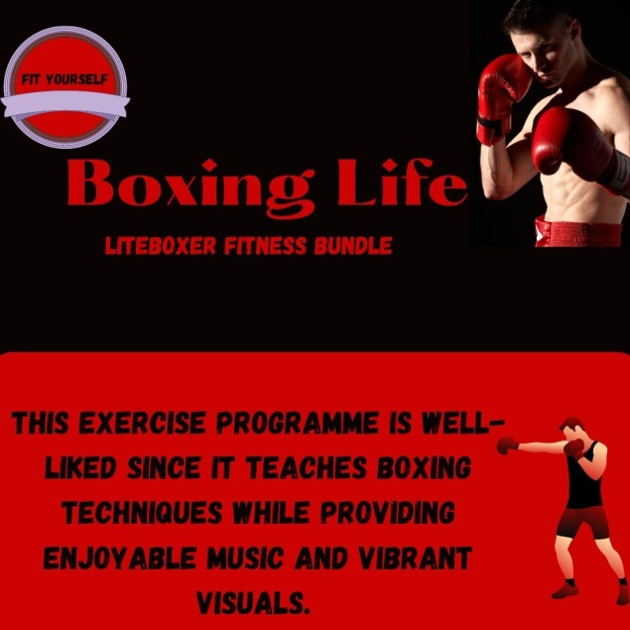

Simply because I have a passion for the sweet science, the sport of boxing, I founded Boxing Life. I hope you have fun and are able to discover something that fits your boxing style. Numerous martial arts, military systems, and other combat sports have adopted boxing techniques. The mat features four resistance settings for a customized workout. The exercise regimen is also effective for total-body conditioning.

This exercise programme is well-liked since it teaches boxing techniques while providing enjoyable music and vibrant visuals. With the **Liteboxers Fitness Bundle**, fitness and weight loss are combined. It's a great approach to maintain your personal fitness while living comfortably.

**Boxer Body**

It has sculpted abs, clearly defined muscles, and a slender appearance overall. Whether you box or not, many men and women strive for the boxer's physique, spending hours in the gym to develop a mean set of abs, muscular shoulders, and bulging biceps.

**Liteboxer Fitness Bundle** and Boxing engages so many of your muscles at once, which is one of the main reasons it's so good for gaining muscle. If we use punching a bag as an example, you might do this repeatedly during a session. You must employ the majority of your upper and lower body muscles throughout that exercise.

**Boxing Rhythm**

Liteboxer is a brand-new kind of at-home gym that combines boxing as well as fitness training. It offers comparable features to other home gyms available on the market in a number of ways. **Features of Liteboxer Fitness Bundle**

* **Developed for punching**

The Liteboxer app's ingenious technology synchronizes music, lighting, and tempo to challenge, monitor, and support you. Every stroke you make is detected and analyzed by the force sensors, 200 LED lights, and six targets on the distinctive shield.

* **Best-in-Class Trainers**

Top-notch trainers are available for sessions as needed. Enroll in workout classes to burn it off. If you're pressed for time, punch tracks pair music with punch; otherwise, get lost in the music.

* **High-Intensity Music**

The music library always has the most popular songs, which keeps people coming back and enjoying the music and exercise. Time seems to fly by as you listen to the music and let your worries go.

* **Actual Results**

Your performance dashboard tracks your progress over time so you can see when you're getting stronger and more fit.

* **New Obstacles**

Competition fosters progress as you keep building your record, punch total, and participating in challenges. Earn points for making strong, precise, and effective punches. Play one-on-one competitions with your friends. As you motivate one another to work harder, keep an eye on your workout partner's development.

**Read the Boxer Free**

Jung Ji-Hoon is the author and illustrator of the webtoon series The Boxer (who is part of Ultra Media). It was first serialized at the end of 2019 on Naver, and at the end of May 2020 it was picked up and hosted on LINE Webtoons. Every Wednesday for Naver and every Thursday for LINE, it is updated.

**Liteboxer Fitness Bundle-FAQs**

**Is the Fitness Bundle from Liteboxer the Best Way to Get Fit?**

With the Liteboxer Fitness Bundle, get in shape! For fitness, the **Liteboxer Fitness Bundle** Package is ideal. Punching bags, gloves, a hands wrap, and heavy bag hanging hooks are included in this pack. High-quality materials that can withstand numerous assaults were used to make the bag.

**Is the Liteboxer Fitness Bundle Subscription-Free?**

The **Liteboxer Fitness Bundle** can be used without a subscription, yes. But you won't have access to things like Boxing Tutorials, Music, Trainers, and Content if you don't have a subscription.

**What kind of material does the Liteboxer punching bag consist of?**

Hard materials, mainly aluminum are used to make **Liteboxer Fitness Bundle** Punch bags. It comes in two options and is stronger than the others. You can select a plan that works for your circumstance.

**Do You Allow Custom Tracks on the Liteboxer Fitness Bundle?**

When you've mastered your few trainer-led sessions, you may use the built-in Punch Tracks to select your own music and box to the beat. You can select a single song or a number of songs to include in your personalized playlist.

**What Stores Sell the Liteboxer Fitness Bundle?**

The Liteboxer fitness package is available via their official website, liteboxer.com. The first connected platform of its kind to allow for at-home exercise. Innovative Rhythm Technology, music, and expert instruction are all combined in the Liteboxer to create an unparalleled full-body boxing workout.

**Conclusion**

If you want to lose weight quickly and effortlessly without investing a lot of money or time in a gymmembership, the **Liteboxer fitness bundle** is ideal. This package comes with a weight loss guide and an exercise guide for your convenience. The coaches will encourage you and push you to get better with every hit.

Additionally, instructors educate students on essential methods and approaches with an emphasis on novices. As a result, it's a desirable choice for making positive lifestyle changes with little disruption. The **Liteboxer fitness bundle's** popularity can be attributed to its effectiveness in helping customers achieve their fitness goals.